BRN-D603 Power Quality Online Monitoring Device
Modbus Protocol V1.1

Category | Content
Keywords | Power Quality, Modbus, RS-485
Abstract | The power quality monitoring terminal employs the Modbus communication protocol for data exchange with the host computer software, enabling real-time monitoring  and management.

Revision History

Version | Date | Reason
V1.0 | 2020-12-24 | Document created
V1.1 | January 21, 2021 | Modified address encoding for system parameters and real-time data sections

目录
1. Basic Overview 1
2. Frame Format 2
3. Address 3
4. Function Code 4
5. Function Code Descriptions 5
5.1 (0x03) Read System Parameters 5
5.1.1 Request 5
5.1.2 Response 6
5.1.3 Interaction Flow 8
5.2 (0x04) Read Real-Time Data 8
5.2.1 Request 8
5.2.2 Response 12
5.2.3 Interaction Flow 13
6. Data Verification 14

Basic Overview
This protocol defines the communication rules between devices and backend software within the power quality monitoring system. It adheres to the standard Modbus communication interface while redefining communication rules to accommodate the characteristics of power quality data.
- The Modbus protocol operates over an RS-485 hardware interface and is a master-slave bus protocol. A single bus can support up to 254 devices, with only one master station permitted; the remaining 253 stations function as slaves. The BRN-D603 device operates as a slave on this bus.
- All session logic follows the "master request → slave response" methodology.
- Data transmission during communication employs big-endian mode.
- This protocol adopts RTU mode and has been adjusted based on the characteristics of power quality data. It redefines the number of requested data items and frame boundaries on top of the standard Modbus protocol.

The serial communication parameters for this protocol are set as follows:
- Data bits: 8 bits
- Stop bits: 1 bit
- Verification method: no parity check

Frame Format
The frame format is as follows:

Address field | Function Code | Data | Error Checking
The frame content interpretation table is shown in Table 2.1.
Table 2.1 Frame Content Interpretation Table

Frame Data Item | Length (bytes) | Description
Address Field | 1 | The address of the station sending this data frame Frame, Destination Address (0x01~0xFF)
Function Code | 1 | Function Code
Data | N
Error Checking | 2 | Use CRC16. The check region starts from the source address and extends to the end of the data area.

Address
When the master station sends data to the slave station, the address field ranges from 0x01 to 0xF7. 0x00 is the bus broadcast address.

Function Code
Function Code | Object Type | Access Type | Function Description
0x03 | 32-bit | Read | Read System Parameters
0x04 | 32-bit | Read | Read real-time data

Function Code Descriptions

(0x03) Read System Parameters
This command retrieves information about system parameters.

Request

Function Code | Start Address High | Start Address Low | High-order Register Count | Number of Registers (Low) | Checksum CRC
0x03 | 0x00 | 0x00 | 0x00 | 0x0N | 0xNNNN
The following lists the parameters for each data item in the request. Each data item occupies 2 registers, totaling 4 bytes. The register addresses corresponding to each data item in the protocol command are shown in the table below:
Table 5.1 Data Item List for

Serial Number | Content | Address Field | Value Unit | Value Type | Space Occupied
0 | Voltage Transformation Ratio | 0x0000~0x0001 | None | Floating-point number | 4
1 | Current transformer coefficient | 0x0002~0x0003 | None | Floating Point Number | 4
2 | Nominal Voltage | 0x0004~0x0005 | V | Floating-point number | 4
3 | Nominal current | 0x0006~0x0007 | A | Floating-point number | 4
4 | Statistical Period | 0x0008~0x0009 | Min | Floating-point number | 4
5 | Statistical Storage Period | 0x000A~0x000B | hour | Floating-point number | 4
6 | Wiring Method | 0x000C~0x000D | None | Floating-Point Number Mapping | 4
7 | Voltage Level | 0x000E~0x000F | V | Floating Point Number | 4
8 | Minimum Short-Circuit Capacity | 0x0010~0x0011 | MVA | Floating Point Number | 4
9 | N-phase PT ratio | 0x0012~0x0013 | None | Floating Point Number | 4
10 | N-phase CP ratio | 0x0014~0x0015 | None | Floating-point number | 4
11 | Is an external zero-sequence transformer connected? | 0x0016~0x0017 | None | Floating-point number | 4
12 | High-frequency limit value | 0x0018~0x0019 | Hz | Floating-point number | 4
13 | Low Frequency Limit | 0x001A~0x001B | Hz | Floating-point number | 4
14 | Short Flash Edge Overlimit Threshold | 0x001C~0x001D | None | Floating-point number | 4
15 | Long Flash Edge Overshoot Threshold | 0x001E~0x001F | None | Floating-point number | 4
16 | Voltage Over-Deviation Threshold | 0x0020~0x0021 | % | Floating-point number | 4
17 | Voltage Undervoltage Threshold | 0x0022~0x0023 | % | Floating-point number | 4
18 | Total Voltage Distortion Threshold | 0x0024~0x0025 | % | Floating-point number | 4
19 | Odd-Harmonic Voltage Content Threshold | 0x0026~0x0027 | % | Floating-point number | 4
20 | Threshold for out-of-limit content of even-order harmonic voltage | 0x0028~0x0029 | % | Floating-point number | 4
21 | SNTP time synchronization interval | 0x002A~0x002B | seconds (s) | Floating-point number | 4
22 | Number of cycles in transient record header | 0x002C~0x002D | None | Floating-point number | 4
23 | Number of Additional Cycles for Transient Recording | 0x002E~0x002F | None | Floating-point number | 4
24-47 | 2nd to 25th harmonic current threshold | 0x0030~0x005F | A | Floating-point number | 96
48-123 | Unused | 0x0060~0x00F7 |  |  | 304
124 | Voltage Negative Sequence Unbalance Threshold | 0x00F8~0x00F9 | % | Floating-point number | 4
125 | Current Negative Sequence Unbalance Threshold | 0x00FA~0x00FB | % | Floating-point number | 4
126 | Voltage zero-sequence imbalance threshold | 0x00FC~0x00FD | % | Floating-point number | 4
127 | Current zero-sequence imbalance threshold | 0x00FE to 0x00FF | % | Floating-point number | 4
128 | Voltage Transient Threshold | 0x0100~0x0101 | % | Floating-point number | 4
129 | Voltage Dip Threshold | 0x0102~0x0103 | % | Floating-point number | 4
130 | Voltage Interrupt Threshold | 0x0104~0x0105 | % | Floating-point number | 4
131 | Inrush Current Threshold | 0x0106~0x0107 | % | Floating-point number | 4

Note:
Wiring Configuration Value Meanings: 50 indicates three-phase four-wire star connection, 33 indicates three-phase three-wire star connection, 35 indicates three-phase three-wire delta connection.

Response

Function Code | Byte Count | Data (N bytes) | Checksum CRC
0x03 | 0x04 | N | 0xNNNN
Response data length = 2 × number of registers.

Error indications are as follows:

Error Code | 1 byte | Function code + 0x8F
Error Code | 1 byte | 0x01, 0x02, 0x03, 0x04
Example: Request to read the nominal voltage of the 5th input parameter, with a value of 12.345, corresponding to memory content 0x1F 0x85 0x45 0x41.

Request |  | Response
Domain Name | (Hexadecimal) | Domain | (Hexadecimal)
Function | 03 | Function | 03
Start Address Hi | 00 | Byte Count | 04
Start Address Lo | 12 | Data field 1 | 1F
Number of Parameters | 01 | Data Field 2 | 85
 |  | Data Field 3 | 45
 |  | Data Field 4 | 41

Interaction Flow
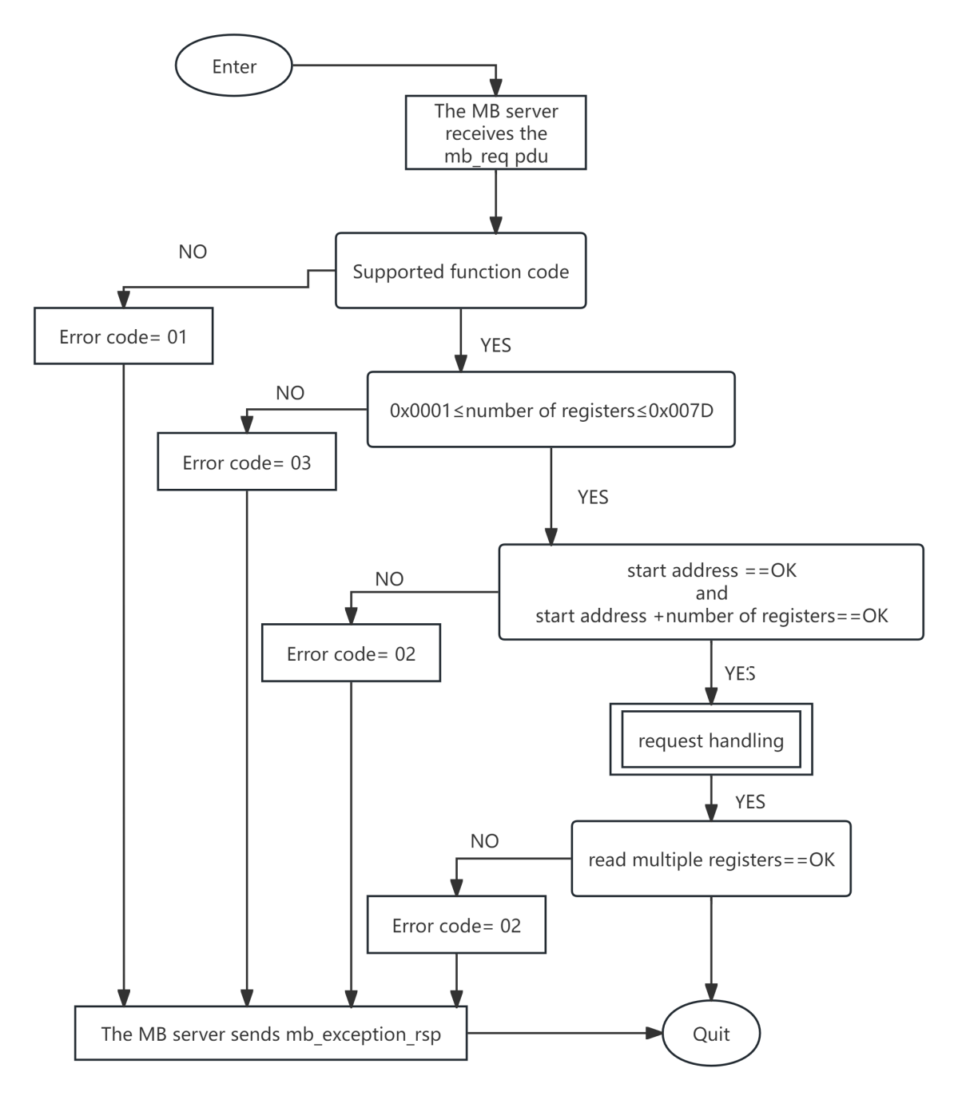
Figure 5.1 Read Hold Register Process

(0x04) Read Real-Time Data

Request

Function Code | High-order Start Address | Start Address Low | High-order Register Count Bit | Number of Registers (Low) | Checksum CRC
0x04 | 0x00 | 0x00 | 0x00 | 0x0N | 0xNNNN
Each pair of registers represents data for one power quality item. The starting address for the nth power quality item is 0x0000 + 2*n. There are 2776 data items in total, as shown in Table 5.3 below.By synthesizing the state diagram for reading input registers in the Modbus protocol and the characteristics of power quality data items, we derive the following state diagram for reading real-time power quality data. Since each data item requires two registers for representation, and the Modbus protocol specifies a maximum of 125 registers for this command,Therefore, when reading real-time data, the maximum number of registers is 125/2, rounded down to 62, and the number of registers must be divisible by 2.
The register addresses corresponding to each data item in the protocol command are listed in the table below:
Table 5.2 List of Data Items for

Content | Start Address | Space Occupied (Bytes)
Phase Voltage RMS (3-phase) | 0 | 12
Line voltage RMS (3-phase) | 6 | 12
Line current RMS (3-phase) | 12 | 12
Frequency | 18 | 4
Forward voltage | 20 | 4
Negative-sequence voltage | 22 | 4
Zero-sequence voltage | 24 | 4
Positive-sequence current | 26 | 4
Negative-sequence current | 28 | 4
Zero-sequence current | 30 | 4
Voltage Negative Sequence Imbalance | 32 | 4
Zero-sequence voltage imbalance | 34 | 4
Current negative sequence imbalance | 36 | 4
Zero-sequence current imbalance | 38 | 4
Voltage deviation (3-phase) | 40 | 12
Short Flicker (3-phase) | 46 | 12
Long flicker (3-phase) | 52 | 12
Fluctuation (3-phase) (Not implemented) | 58 | 12
Fluctuation Frequency (3-phase) (Not Implemented) | 64 | 12
Total Harmonic Voltage Distortion (3-phase) | 70 | 12
Total Harmonic Current Distortion (3-phase) | 76 | 12
Fundamental Harmonic Voltage RMS (3-phase) | 82 | 12
Fundamental Harmonic Current RMS (3-phase) | 88 | 12
Harmonic voltage RMS (3-phase total 189 data points) | 94 | 756
Harmonic current RMS (3-phase total 189 data points) | 472 | 756
Harmonic voltage content rate (189 data points total for 3 phases) | 850 | 756
Harmonic current content rate (3-phase total 189 data points) | 1228 | 756
Harmonic voltage phase angle (189 data points total for 3 phases) | 1606 | 756
Harmonic Current Phase Angle (3-phase total 189 data points) | 1984 | 756
Interharmonic voltage RMS (150 data points total for 3 phases) | 2362 | 600
RMS value of harmonic currents (150 data points for 3 phases combined) | 2662 | 600
Interharmonic voltage content rate (150 data points total for 3 phases) | 2962 | 600
Interharmonic current content rate (3-phase total 150 data points) | 3262 | 600
High-frequency harmonic voltage RMS (105 data points total for 3 phases) | 3562 | 420
High-frequency harmonic current RMS (3-phase total 105 data points) | 3772 | 420
Active Power (3-phase and total) | 3982 | 16
Reactive Power (3-phase and total) | 3990 | 16
Apparent Power (3-phase and total) | 3998 | 16
Power Factor (3-phase and total) | 4006 | 16
Displacement Power Factor (3-phase and total) | 4014 | 16
Harmonic Active Power (189 data points total for 3 phases) | 4022 | 756
Harmonic reactive power (3-phase total 189 data items) | 4400 | 756
Harmonic Apparent Power (3-phase, 189 data items total) | 4778 | 756
Total Harmonic Active Power (63 data points) | 5156 | 252
Total Harmonic Reactive Power (63 data points) | 5282 | 252
Total Harmonic Apparent Power (63 data points) | 5408 | 252
Total Harmonic Active Power (3-phase) | 5534 | 12
Total Harmonic Reactive Power (3-phase) | 5540 | 12
Total Harmonic Apparent Power (3-phase) | 5546 | 12
Real-time Demand (3-phase) | 5552 | 12
Daily Positive Active Energy (3-phase) | 5558 | 12
Daily Reverse Active Energy (3-phase) | 5564 | 12
Daily Forward Reactive Energy (3-phase) | 5570 | 12
Reverse Reactive Energy Consumption (3-Phase) | 5576 | 12
Daily Maximum Demand (3-phase) | 5582 | 12
Maximum Daily Demand Time (3-phase) | 5588 | 12
Monthly Positive Active Energy (3-phase) | 5594 | 12
Reverse Active Energy for the Month (3-phase) | 5600 | 12
Current month forward reactive energy (3-phase) | 5606 | 12
Reverse reactive energy for the month (3-phase) | 5612 | 12
Maximum Demand for the Month (3-phase) | 5618 | 12
Monthly Maximum Demand Time (3-phase) | 5624 | 12
Number of Voltage Transient Events on the Day | 5630 | 4
Number of voltage dip events on the day | 5632 | 4
Number of voltage interruptions on the day | 5634 | 4
For example: The 5th data item is the phase B line voltage RMS value, with a starting address of: 8 (0x0008).
Note: The demand time data structure represents the number of seconds since January 1, 1900, 00:00:00 (UINT type).

Response
A normal response command frame is described as follows:

Function Code | Data Length | Data | Checksum CRC
0x04 | 0x00 | 2*N | 0xNNNN
Error representation is as follows:

Error Code | 1 byte | 0x84
Error Code | 1 byte | 0x01, 0x02, 0x03, 0x04

Example: Request to read the value of the 5th power quality data item, B-phase current, i.e., retrieve the values from registers 9 and 10. The B-phase current value is 12.345, with the corresponding memory content being: 0x1F854541. The data is encoded in big-endian mode according to the Modbus protocol.

Request |  | Response
Domain Name | (Hexadecimal) | Domain Name | (Hexadecimal)
Function | 04 | Function | 04
Start Address Hi | 00 | Byte Count | 04
Start Address Lo | 09 | Input Register 9Hi | 1F
Number of Input Registers 9Hi | 00 | Input Register 9Li | 85
Number of input registers 9Li | 02 | Input register 10Hi | 45
 |  | Input Register 10Li | 41

Interaction Flow
The data communication status diagram is shown below.
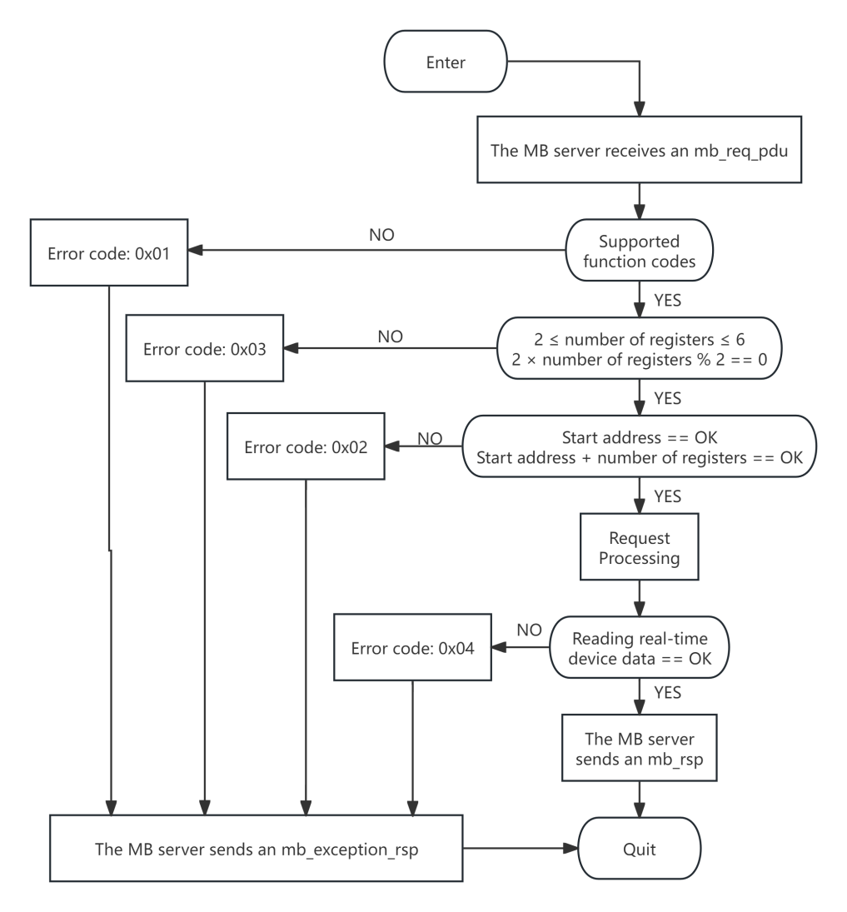
Figure 5.2 Real-Time Data Reading Status Diagram

Data Verification
Data transmission relies on the transmission mode, with both verification modes employed: RTU or ASCII. The protocol defaults to RTU mode. In RTU mode, an error verification field based on the Cyclic Redundancy Check (CRC) algorithm is included, applied to the entire message content. The CRC field verifies the entire message content. This verification is performed regardless of whether the message has parity.

